PRO192- Practice Exam – SP25 23/3/2025
Duration: 85 minutes
Develop a Fruit Shop Management OOP application with the following components and requirements
- Create MVC console application in NetBeans:
  - Define class Fruit with the following attributes and methods: (1.5 marks)
+ name(string), price (double), quantity(int), packagingDate (LocalDate).
+ Constructors, get/set(), toString() (in which display the Date attribute in the format “yyyy-MM-dd”).
Note: No IO console is used in this model class
  - Define a class FruitList to manage the list of fruit has the following methods: (3.0 marks)
+ Read text file to load data for FruitList – FruitsList.txt is provided (1.0 mark)
+ Method that can add a new fruit (check this name does not exist in the list is required) (0.5 mark)
+ Method that can delete a Fruit in the list if its quantity is less than 2 (0.5 mark)
+ Method that can sort the Fruit list by ascending order of name(0.5 mark)
+ Method that can calculate the total price of fruits in the list while applying discounts based on quantity:
quantity >=100 then discount rate is 10%
quantity>=50 then discount rate is 5% (0.5 mark)
Note: No IO console is used in this model class
  - Develop FruitController class to run the application (4.0 marks)
+ Main menu for application includes: Display all fruits, Add a new fruit, Delete a fruit if its quantity is less than 2, Sort the list by name, Total after discount, Quit (0.5 mark)
Hint: An abstract Menu class is provided for use in the application.
+ Display all fruits (0.5 mark)
+ Method for adding new fruit from console (0.5 mark)
+ Method for deleting a fruit (1.5 mark)
+ Method for sorting the list by name (0.5 marks)
+ Method for calculating total cost after discount (0.5 marks)
+ main() method to run the program
Note: This class allows interaction with user IO from the console.
- Technical requirements (1.5 marks):
+ Create a package model for Fruit and FruitList class. (0.5 mark)
+ Create package view_controller for Menu and FruitController class. (0.5 mark)
+ Please handle every exception for adding a new fruit function, asking the user to re-enter for incorrect input data. (0.5 mark)
+ User view should be as follows:
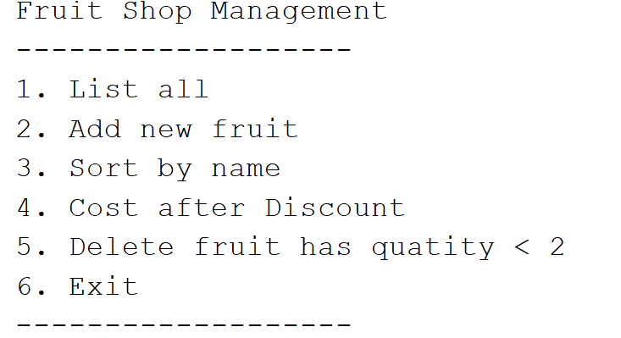
+ The list of bills may look like this:
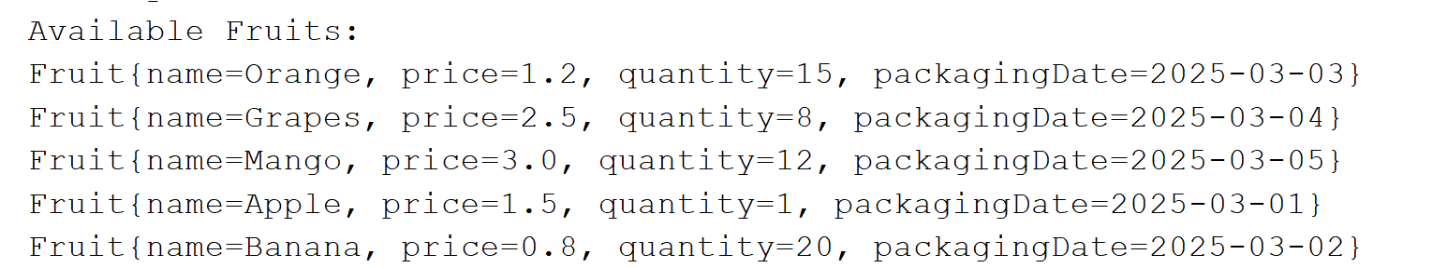
Notice:
1. An abstract Menu class is provided to create a menu in developing this application.
2. Students must strictly follow all requirements as described above for marking. Any
modification of the requirement details is not allowed and will receive 0 marks!
3. Students must submit the project folder (created in NetBeans), submitting any other file formats (such as .doc, .txt…) will receive 0 marks.

